# ANALYSING HOUSING PRICES IN METROPOLITAN AREAS OF INDIA

1. INTRODUCTION:

Since ,the inception of the theory and idea of development, the common feature that emerged in different point of time is the developmental gap that emerged in different parts of the world and also among various parts of a country in a particular time period. This disparity in development, like many other indicators, has also been reflected in India, Traditional development theories believed that agriculture, industrialization, urbanisation, are significant ingredients of growth, and, ultimately important prerequisites for achieving development. Within the economy itself, the status of growth of a state can be judged through its performance in agriculture and industrial production, performance of service sector and urbanization, and their impact through their contribution in income and employment generation at the national level. Thus, house price behaviour may also reflect some short of developmental status of the households of a country.

1.1 OVERVIEW:

The Times of India (2012) report indicates that housing prices in India witnessed the steepest rise in the world in the last 10 years since 2001. “House prices in India have increased by 284% in real terms, after allowing for inflation-equivalent to an average annual rise of 14%. The upward movement could be due, significantly, to, rapid urbanization, increase in population, migration from rural areas as a result of unsatisfactory performance in agriculture and expectation for better livelihood,in terms of greater earning possibilities in urban areas.

1.2 PURPOSE:

Housing, or more generally, living spaces, refers to the construction and assigned usage of houses or buildings individually or collectively, for the purpose of shelter. Housing is a basic human need, and it plays a critical role in the shaping the quality of life for individuals, families, and communities.

2.PROBLEM DEFINITION & DESIGN THINKING

2.1 Empathy Map

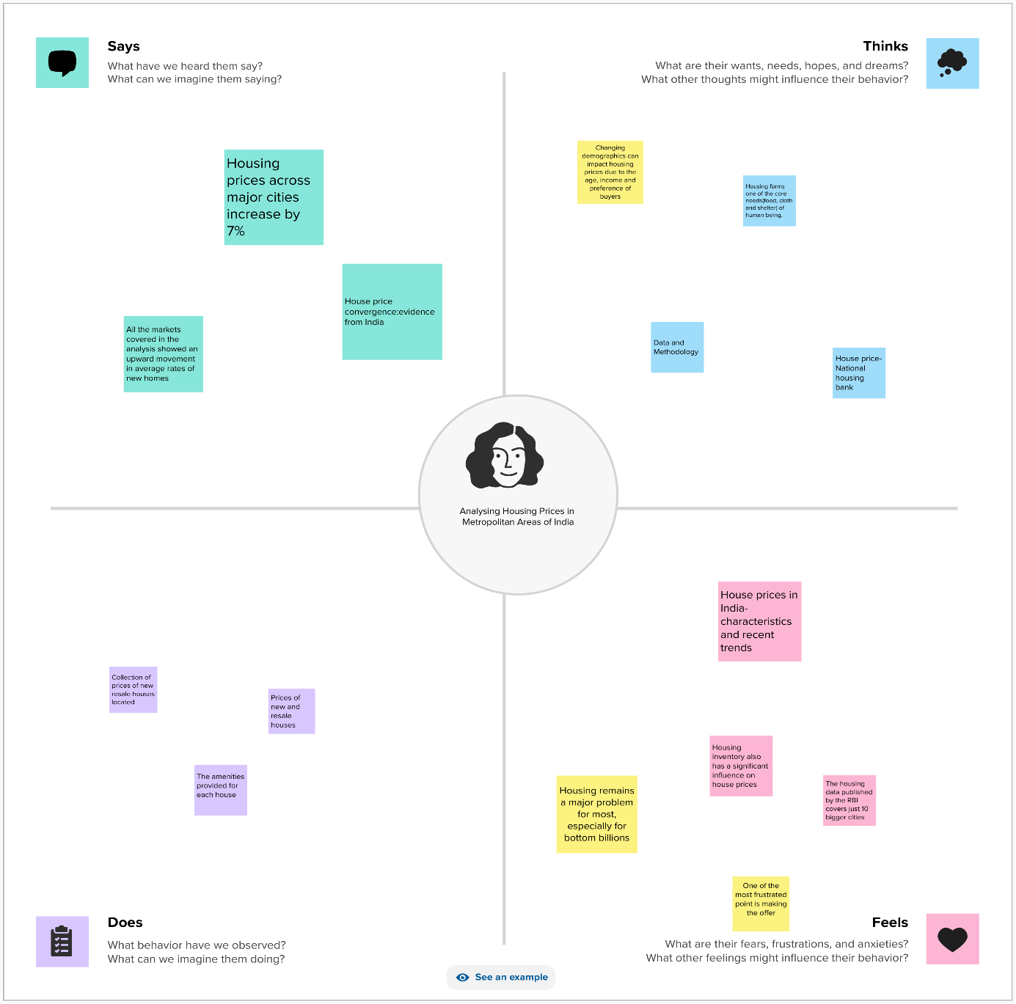

2.2 Ideation & Brainstorming Map

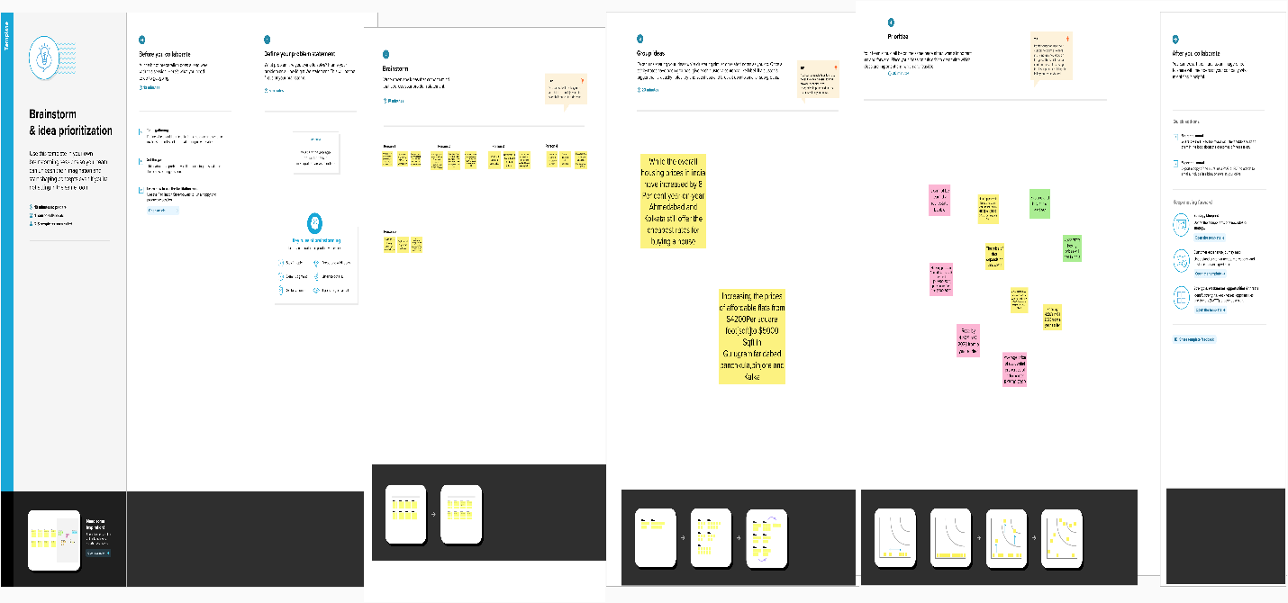

3.RESULT

3.1 Dashboard 1

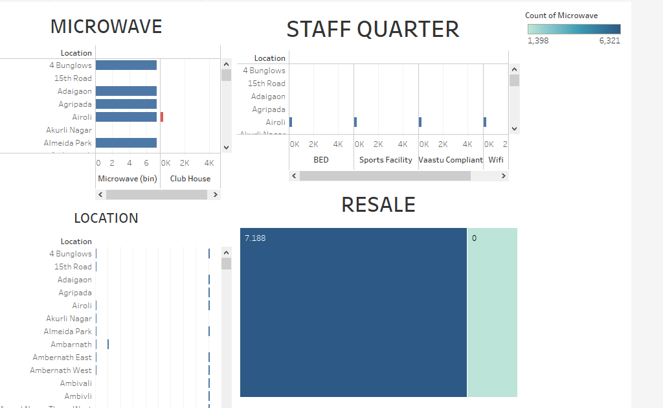

3.2 Dashboard 2

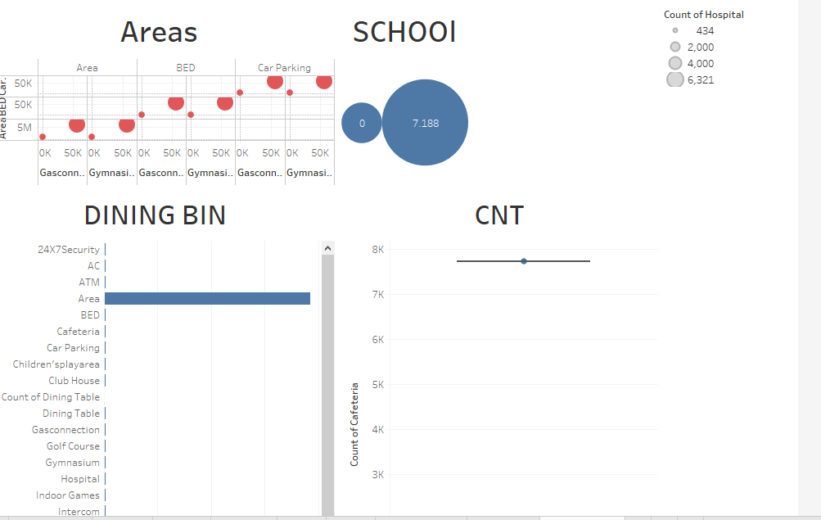

4. Story

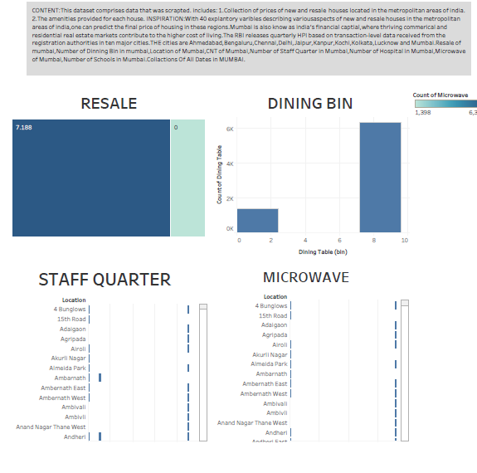

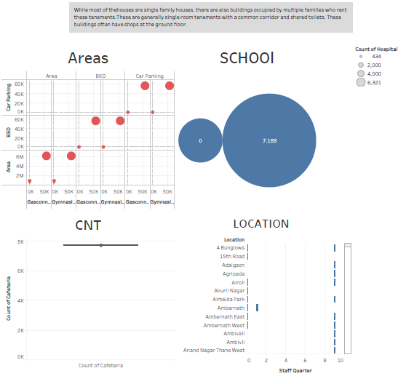

5. ADVANTAGES

* High-speed public transit system in the form of Metro/Monorail/Metrolite/RRTS/MRTS
* High-speed internet access in the form of fiber and 5G.
* One-day delivery of products including essentials like medicines and groceries.
* Facilites of docter-at-home and ease of access of medical.
* Wide varieties of restaurants to order.
* Presence of an international Airport.
* Head Offices of institutions, banks, boards, etc. are located.
* Modern Infrastructure and better application of technology.

6. DISADVANTAGES

* High cost of rent and food.
* Overpopulation and pollution.
* Increased competition and societal callousness.
* You miss your tradition and culture.
* High level of population.
* Safety for women and children , is an issue.

7. APPLICATION :

Housing application for the allocation of a Rental Unit and which will be available upon request from the Housing Department. An application to the court under the Residential Tenancies Act, Tenancy Act or Business Tenancies(Fair Dealings) Act other than a summary possession application or retail tenancy claim;

8. CONCLUSION:

This paper analyzes whether the Law of One Price (LOOP) holds in the housing market of fifteen metropolitan areas in India, namely Delhi, Mumbai, Bengaluru, Kolkata, Chennai, Jaipur, Lucknow, Hyderabad, Pune, Surat, Ahmedabad, Patna, Faridabad, Kochi and Bhopal. We test the existence of LOOP using the Im, Pesaran and Shin (2003) panel unit root test based on quarterly data on residential property prices covering the period of 2007Q1 to 2011Q4 of the Indian housing market. Based on the criterion of prices in the 15 metropolitan cities do not converge to the LOOP.

9. FUTURE SCOPE:

Increasing urban migration is driving demand for rental housing, leading to growth in the rental market. Co-Living and co-working: These trends are expected to continue as the younger generation seeks flexible and community-oriented living and working arrangements.